**User Manual**

**of**

**Accounting System**

**for**

**Dhaka Wasa**

**Login & Logout**

**Login Page:** Log in page is the starting page for any user. Any authorized user can log in to the accounting system by giving his/her ID and password. If both ID and password match, then that user can use then system according to user permission.

Now the process of using this page is following:

**1.Login Process**

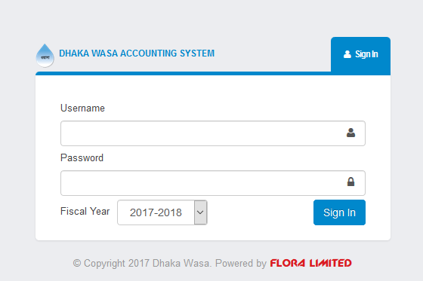

**Screen Shot: 01**

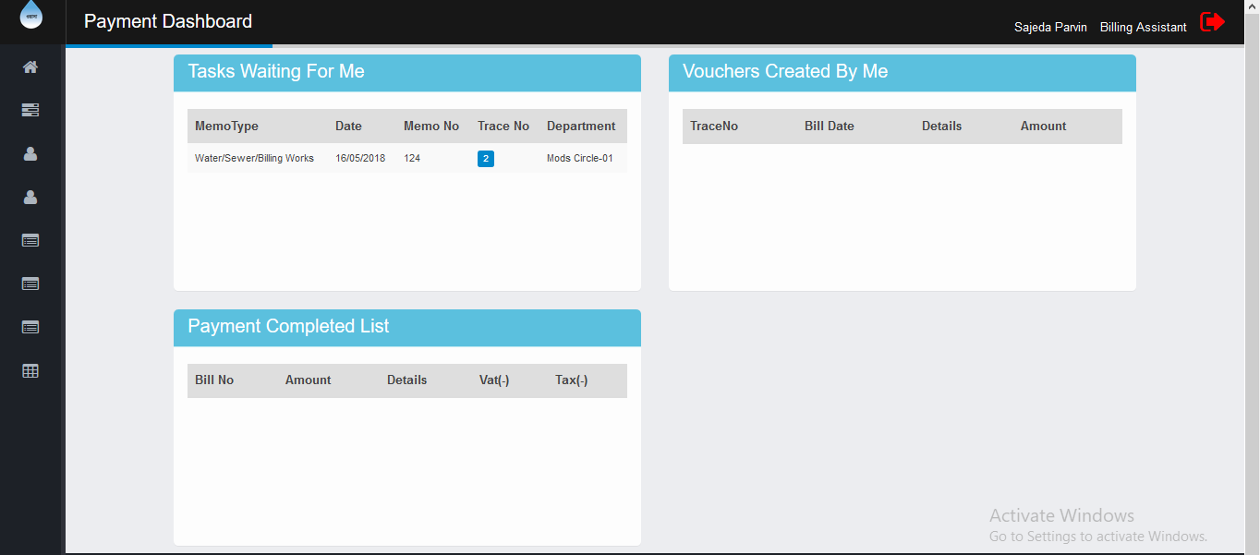

**Screen Shot: 02**

In Screen Shot 01 a user has to fill up his/her Username and Password and has to select Fiscal Year then has to click Sign in button. After clicking Sign in button Payment Dashboard will be displayed, which is on Screen Shot 02. Payment dashboard is contains Task Waiting to be performed, Vouchers still in approval process, last 20 completed payments of logged user.

**Logout:** If user wants to close or logout from the system, user can find a logout link when clicking on the red exit sign at top right corner. Users can logout from any page like following:

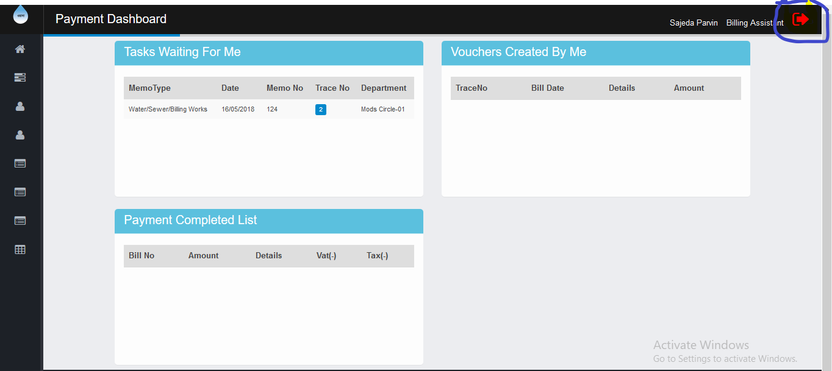

**Screen Shot: 03**

On Screen Shot 02 user has to click logout and after clicking logout login page will display for a new login.

**Account Setup**

1. **Financial Year Setup Page:** In this page the financial year for accounting is set up so that a user can show easily any types of information according to financial year. Now the process of use this page is following:

**Go to page:**

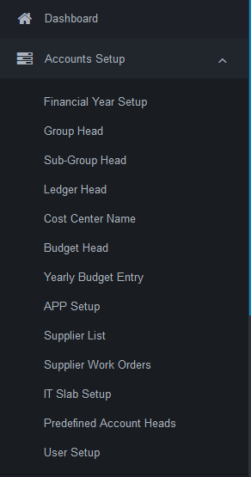

**Screen Shot: 04**

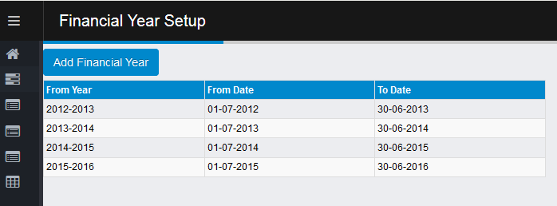

**Screen Shot: 05**

In screen Shot 04 a user has to click ‘Accounts Setup’ at first and then has to click ‘Financial Year Setup’. After clicking that the page will display.

**Insert Financial Year:**

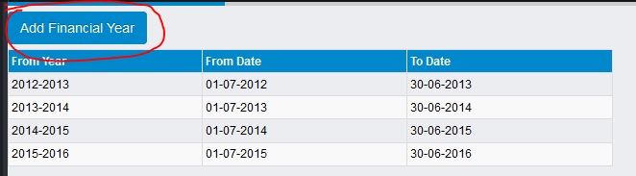

**Screen Shot: 06**

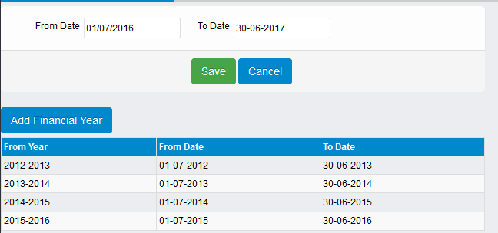

**Screen Shot: 07**

**2. Group Head Page:** In this page Account Group Head information is stored according to Account Type. The process of using this page is following:

**Go to Page:**

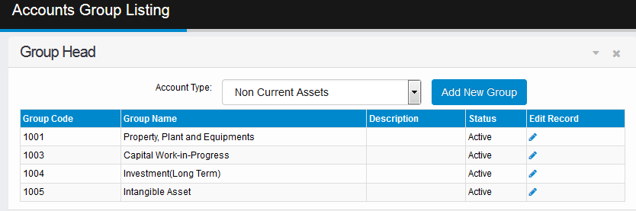

**Screen Shot: 10**

To visit this page user has to Click ‘Account Setup’ and then again click to ‘Group Head’ which is on Screen Shot 10. Then the page will display as Screen Shot 10.

**Insert Group Head:**

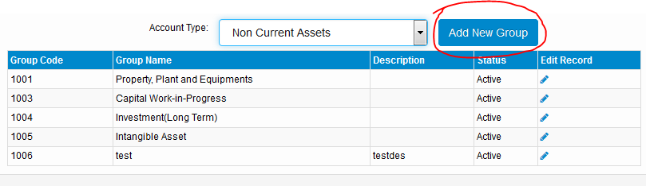

**Screen Shot: 11**

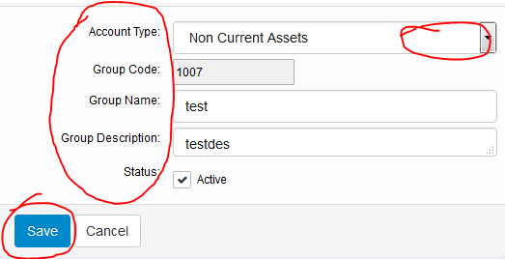

**Screen Shot: 12**

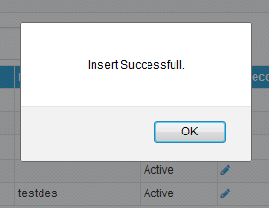

**Screen Shot: 13**

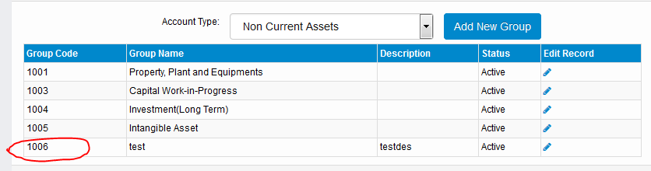

**Screen Shot: 14**

To save a Group Header at first user has to click on ‘Add New Group’ button which is on screen shot 11 then user has to fill up required fields and click to save button that is on screen shot 12. After saving data a message will display (Screen Shot 13). Then the new data will be added in grid view (Screen Shot 14)

**Update Group Head:**

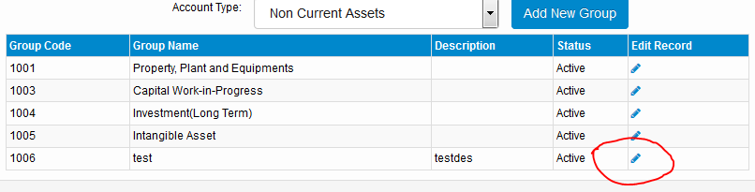

**Screen Shot: 15**

To update a data user go to ‘Edit Record’ column and select a row which user want to Edit and then click that column (Screen shot 15)

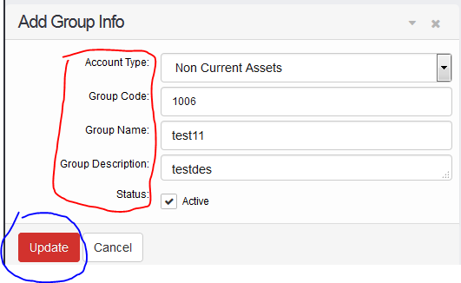

**Screen Shot: 16**

Then user has to fill up required fields that he wants to update and then click to ‘Update’ button (Screen Shot 16)

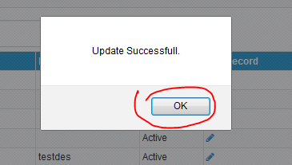

**Screen Shot: 17**

After update data a message will display and then click OK to return (Screen Shot 17).

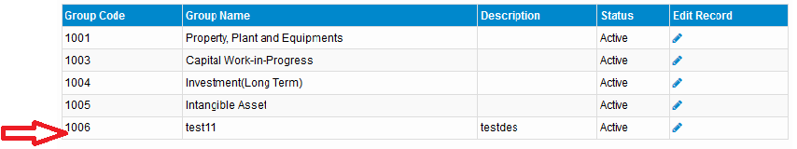

**Screen Shot: 18**

That data has been updated successfully (Screen Shot 18).

**3. Sub Group Head Page:** In this page Account Subgroup Head information is stored according to Account Type and Account Group. The process of using this page is following:

**Go to page:**

**Screen Shot: 19**

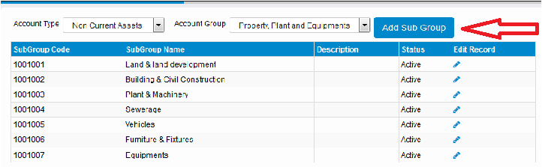

**Screen Shot: 20**

To visit this page user has to Click ‘Account Setup’ and then again click to ‘Subgroup Head’ (Screen Shot 19) and the page will display and then click to ‘Add Sub Group’ button to add (Screen Shot 20)

**Insert Subgroup Head**

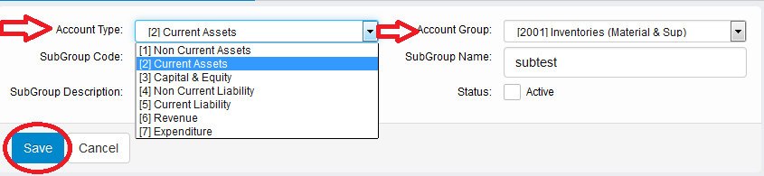

**Screen Shot: 21**

After clicking ‘Add Sub Group’ button the fields are open and user must have to select ‘Account Type’ at first and ‘Account Group’ will display according to ‘Account Type’ and then select Group also. After fill up all fields click to ‘Save’ button (Screen Shot 21)

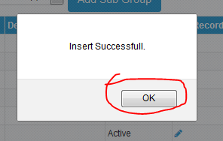

**Screen Shot: 22**

After inserting data successfully, a message will display and then click OK to return (Screen Shot 22)

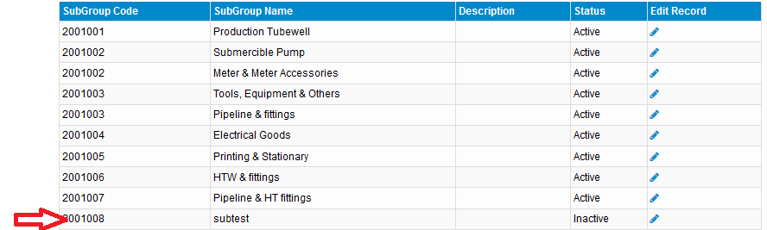

**Screen Shot: 23**

Then data has been insert successfully and show in grid view (Screen Shot 23)

**Update Subgroup Head**

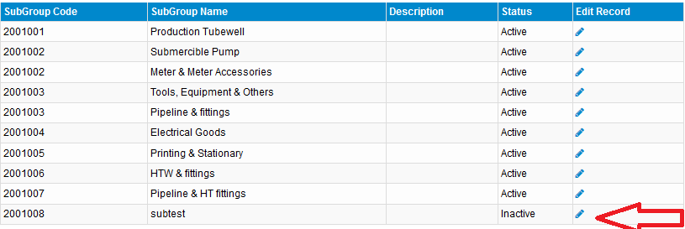

**Screen Shot: 24**

To update a row user has to click on ‘Edit Record’ column (Screen Shot 24)

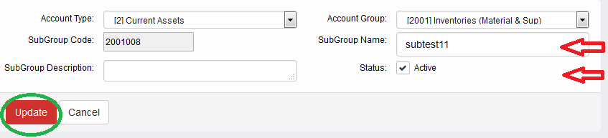

**Screen Shot: 25**

After filling up required fields user has to click on ‘Update’ button (Screen Shot 25)

**4. Ledger Head Page:** In this page Ledger Head information is stored according to Account Type and Account Group and Subgroup. The process of using this page is following:

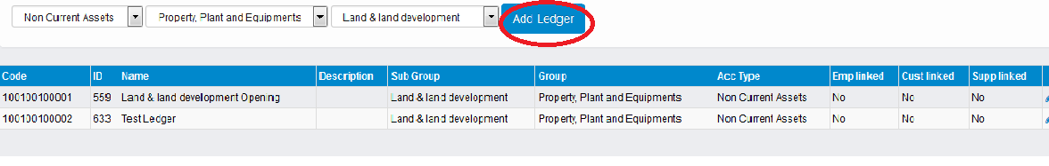

**Screen Shot: 28**

To visit this page user has to Click ‘Account Setup’ and then again click to ‘Ledger Head’ (Screen Shot 27) and the page will display and then click to ‘Add Ledger’ button to add (Screen Shot 28)

**Insert Ledger Head**

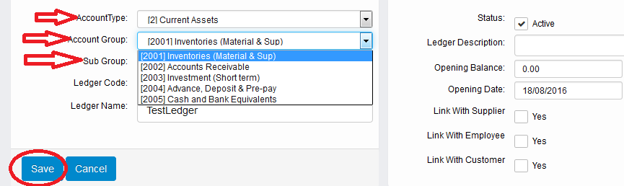

**Screen Shot: 29**

After clicking ‘Add Ledger’ button the fields are open and user must have to select ‘Account Type’, ‘Account Group’, ‘Sub Group’ at first and ‘Account Group’ will display according to ‘Account Type’ and ‘Sub Group’ will display according to ‘Account Group’. After fill up all fields click to ‘Save’ button (Screen Shot 29)

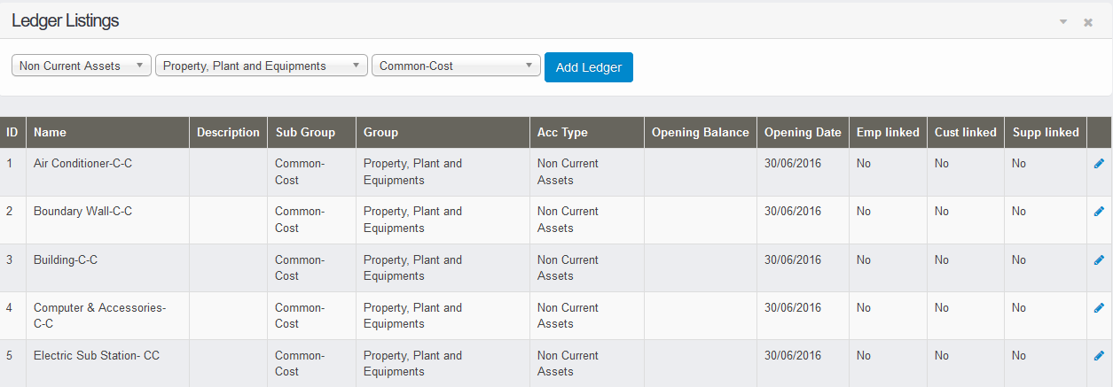

**Screen Shot: 30**

Then data has been inserted successfully and show in Grid Table (Screen Shot 30)

**Update Ledger Head**



**Screen Shot:32**

To update a data user go to ‘Edit Record’ column and select a row which user want to Edit and then click that column (Screen shot 32)

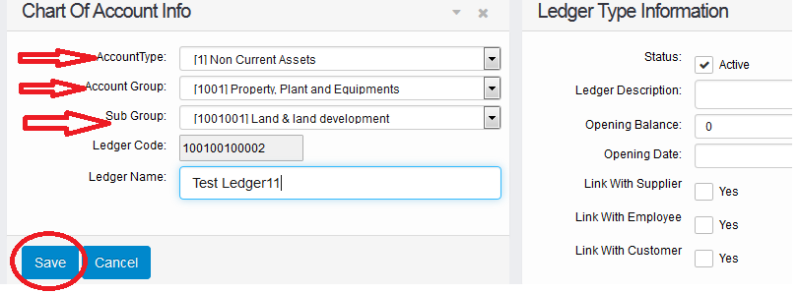

**Screen Shot: 33**

After fill up required fields user has to click on ‘Save’ button (Screen Shot 33)



**Screen Shot: 35**

Then data has been updated successfully and show in grid view (Screen Shot 35)

**5. Cost Centre Name Page:** In this page Cost Centre information is stored. The process of using this page is following:

**Go to page**

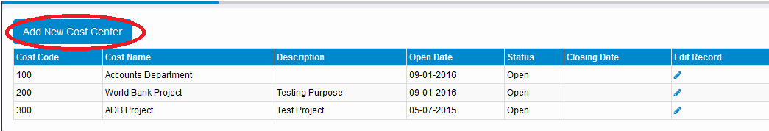

**Screen Shot: 37**

To visit this page user has to Click ‘Account Setup’ and then again click to ‘Cost Centre Name’ (Screen Shot 36) and the page will display and then click to ‘Add New Cost Centre’ button to add (Screen Shot 37)

**Insert Cost Centre**

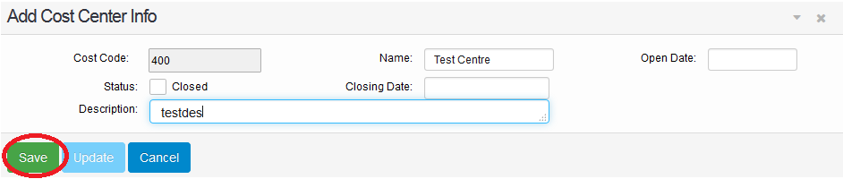

**Screen Shot: 38**

After clicking ‘Cost Centre Name’ button the fields are open. After fill up all fields click to ‘Save’ button (Screen Shot 38)

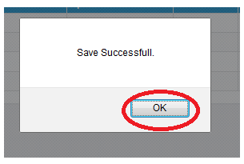

**Screen Shot: 39**

After inserting data successfully, a message will display and then click OK to return (Screen Shot 39)

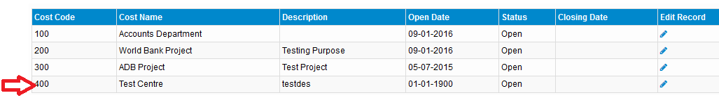

**Screen Shot: 40**

Then data has been inserted successfully and show in grid view (Screen Shot 40)

**Update Cost Centre**

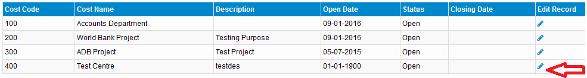

**Screen Shot: 41**

To update a data user go to ‘Edit Record’ column and select a row which user want to Edit and then click that column (Screen shot 41)

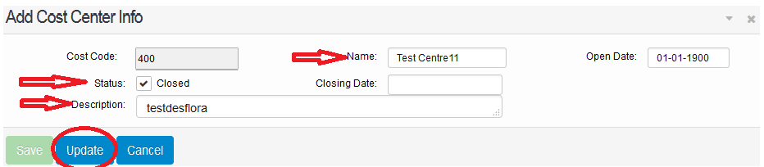

**Screen Shot: 42**

After fill up required fields user has to click on ‘Update’ button in Add Cost Center Info page.

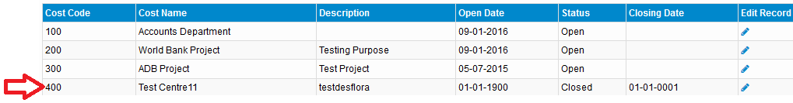

**Screen Shot: 44**

**6. Budget Head page:** In this page Budget information is stored. The process of using this page is following:

**Go to page**

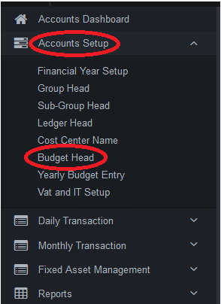

**Screen Shot: 45**

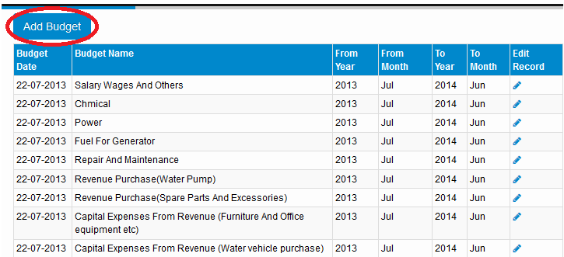

**Screen Shot: 46**

**Insert Budget**

To visit this page user has to Click ‘Account Setup’ and then again click to ‘Budget Head’ (Screen Shot 45) and the page will display and then click to ‘Add Budget’ button to add (Screen Shot 46)

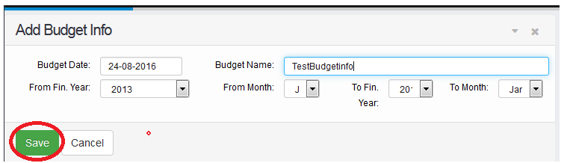

**Screen Shot: 47**

After clicking ‘Add Budget’ button the fields are open. After fill up all fields click to ‘Save’ button (Screen Shot 47)



**Screen Shot: 48**

After inserting data successfully, a message will display and then click OK to return (Screen Shot 48)

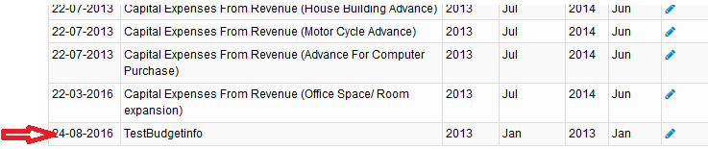

**Screen Shot: 49**

Then data has been Inserted successfully and show in grid view (Screen Shot 49)

**Update Budget**

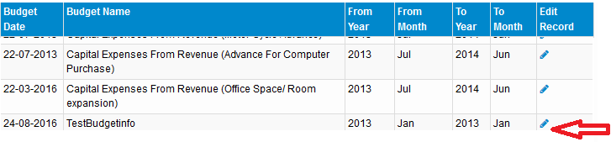

**Screen Shot: 50**

To update a data user go to ‘Edit Record’ column and select a row which user want to Edit and then click that column (Screen shot 50)

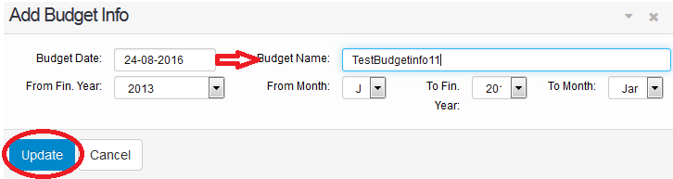

**Screen Shot: 51**

After filling up required fields, user has to click on ‘Update’ button (Screen Shot 51)

**7. Yearly Budget Entry:** In this page Yearly Budget information is stored. The process of using this page is following: To add new Budget Info click Add Budget Ceiling.

**Go to page**

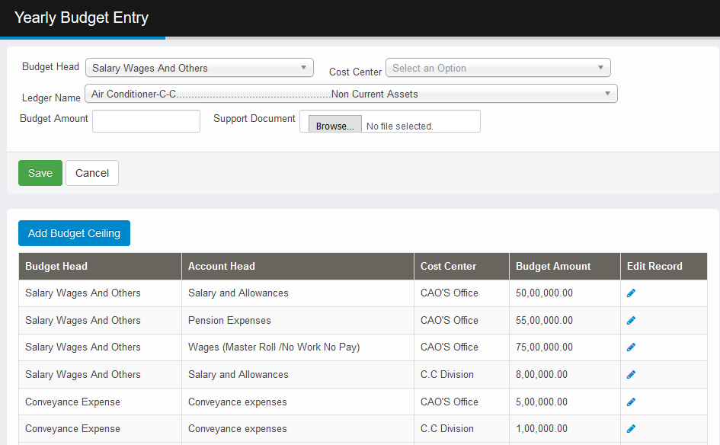

**8. APP Setup:**  In this page annual procurement plan for different Budget for corresponding Cost Center is shown for a fiscal year. For add an item in procurement plan click Add New Package.

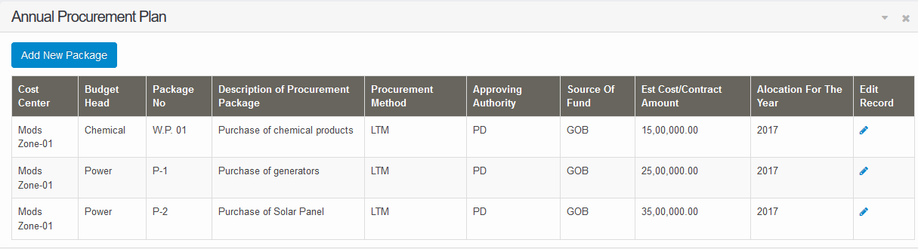

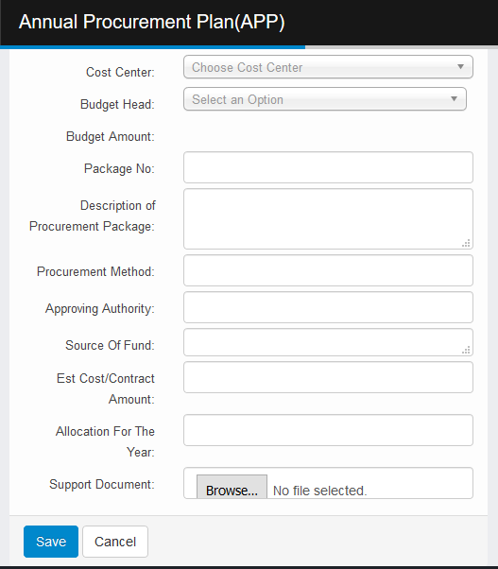

**9. Supplier List:**  By Clicking Supplier List in Menu one can view a supplier list. To add a Supplier click Add New Supplier Button.

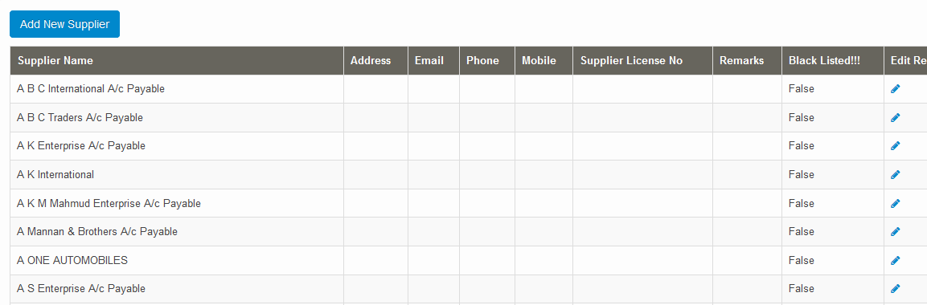

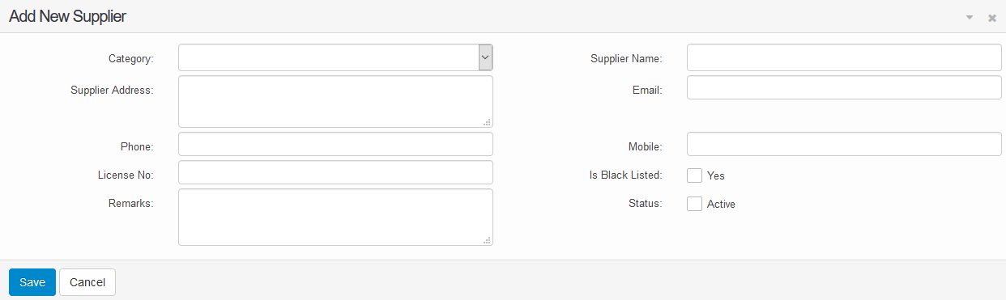

**10. Work Orders:**  By clicking Supplier Work Order one can view the Work orders made for Suppliers and one can add a new Work order by clicking Add New Work Order. Put information and save the work order.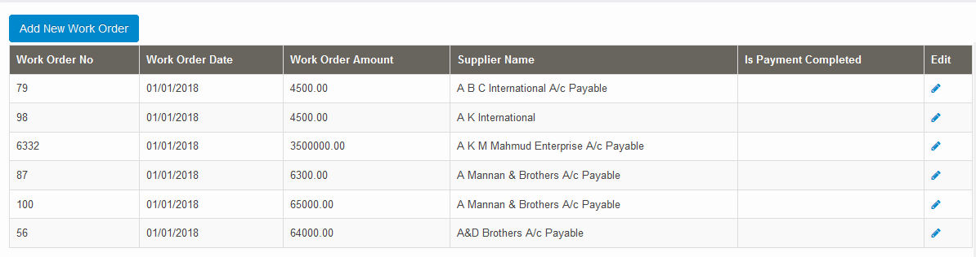 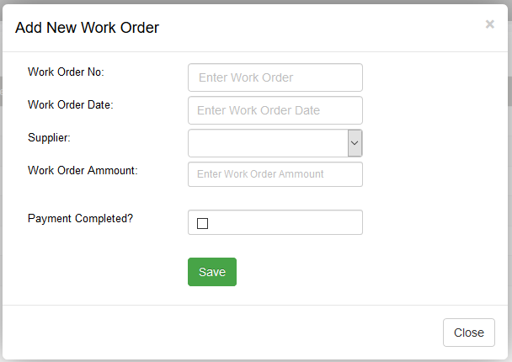

**11. Income Tax Slab Setup:**  By Clicking IT slab setup from menu user can view the Income Tax Slab Setup Page. To add click Add tax slab.

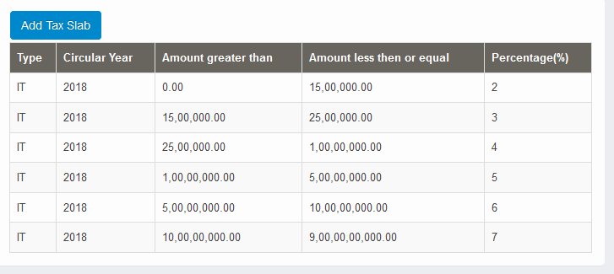

**8. User Setup:** In this page user information is stored. The process of using this page is following:

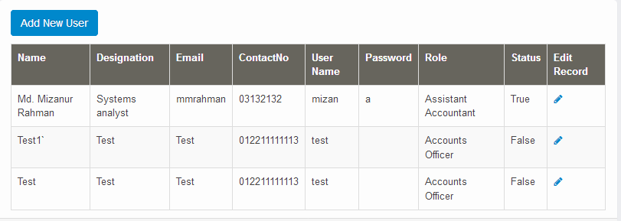

**Add a new User**

To create a new user, click on “Add New User” button.Then below page will appear. Fill the require information and click on save button.

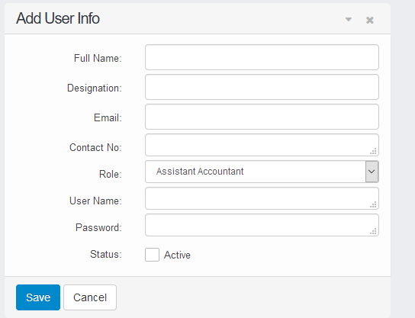



**Edit Existing User:**

To edit existing user, Click on edit button from the “Edit Record” column. It will show below page. After filling information, click on update button. After finishing updating, it will show a message.

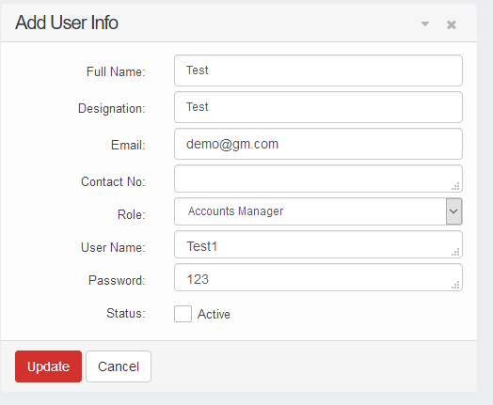

**Accounts Payable:**

**1. General Bill Register:** In this page all approved and unapproved bill register will displayed between to date periods.

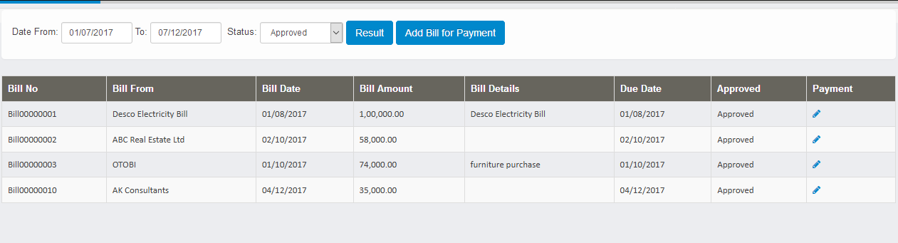

**Add new bill:**To add new bill, click on “Add Bill for payment” button. Then below window will open. After that need to fill require information and click on to “Save Bill” button.

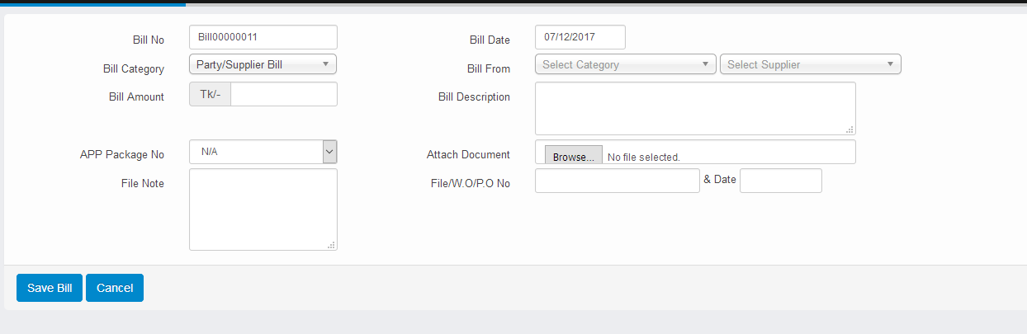

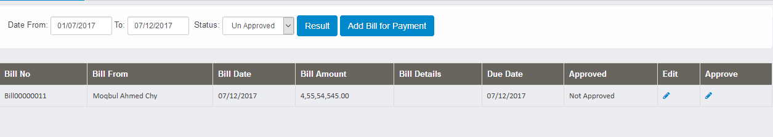

Last added bill will be not approved until higher authority approve it. To approve bill, click on approve button from approve column, and then click on approve button. Then the bill will be listed on the approved bill list.

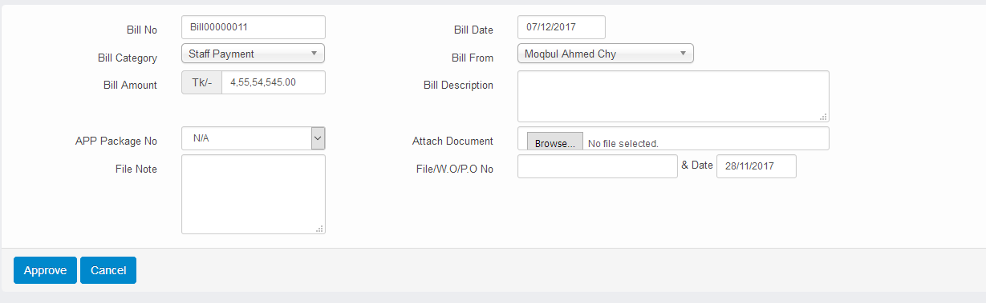

**Edit Bill:**To edit bill click on edit button from payment column. After that below window will appear. Then fill the require information and click on save button.

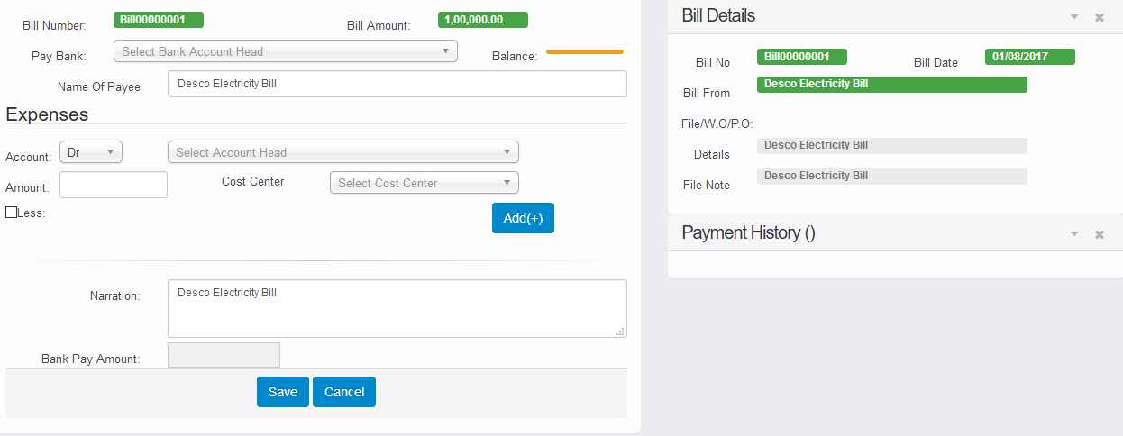

**2. Unapproved Payment Vouchers:**In this page unapproved payment vouchers will displayed.

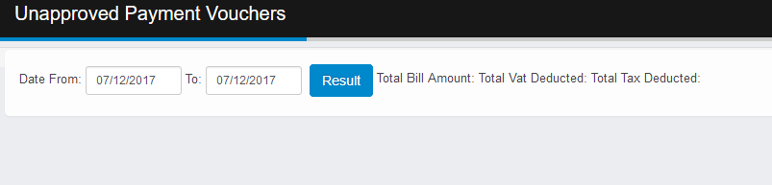

**3. Checks to be issued list:**In this page, checks which need to be issued will be displayed.

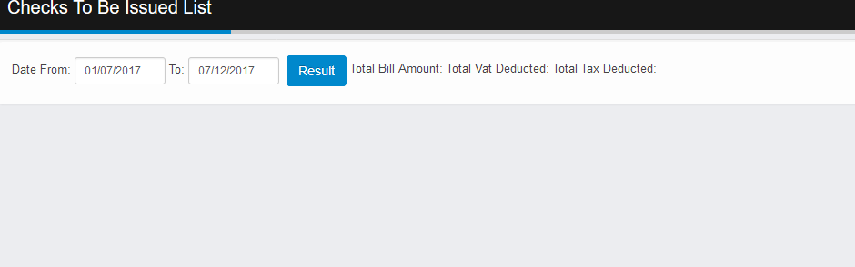

**4. Payment Archived:**In this page, payment which are archived will displayed.

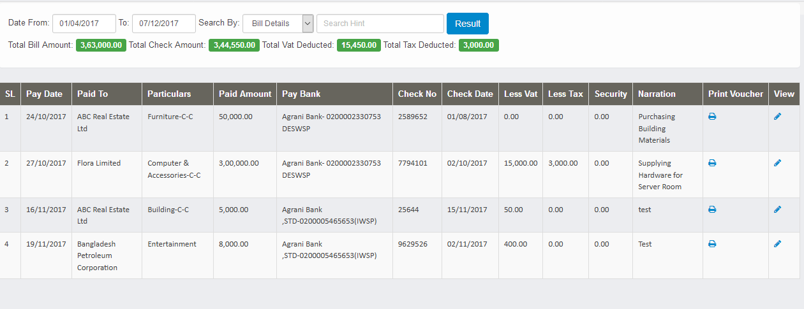

Here we can print the voucher by clicking Print button on the Print voucher column. For viewing “Payment archive” data, need to click on view button of “View column”.

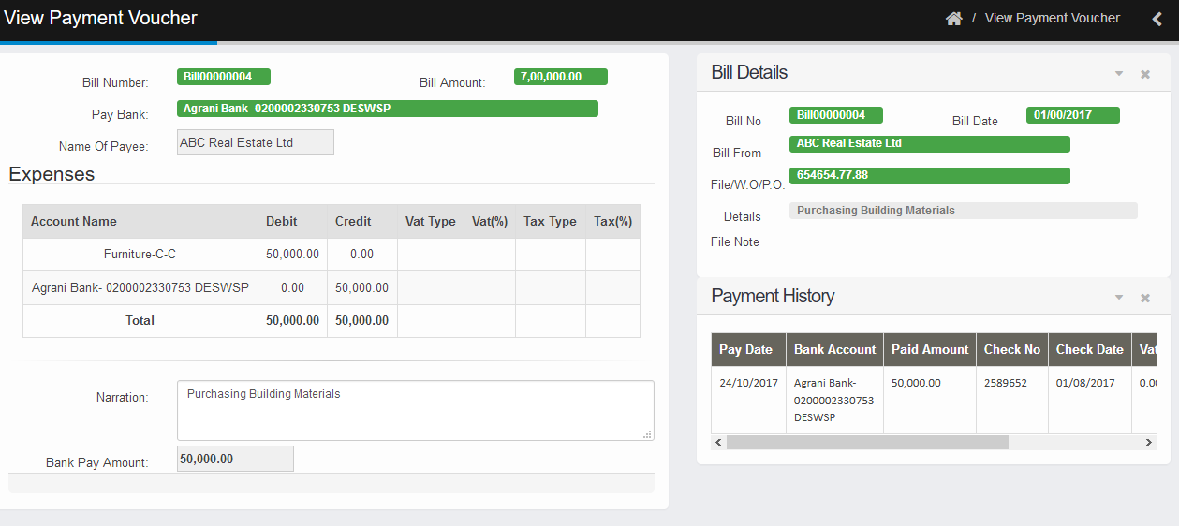

**5. Supplier ledger:**In this page, supplier payment history will be displayed.

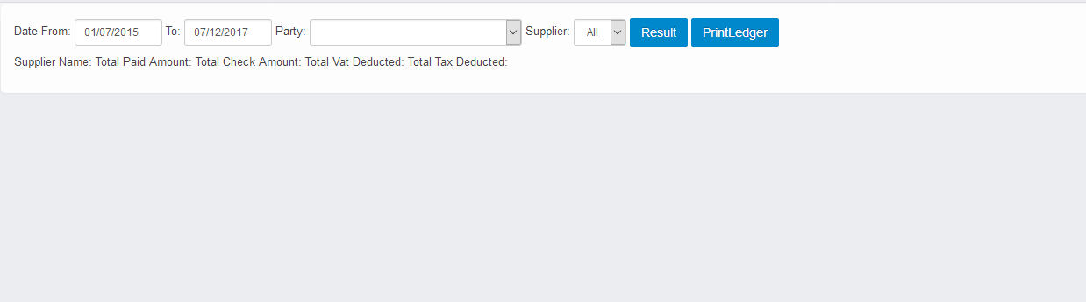

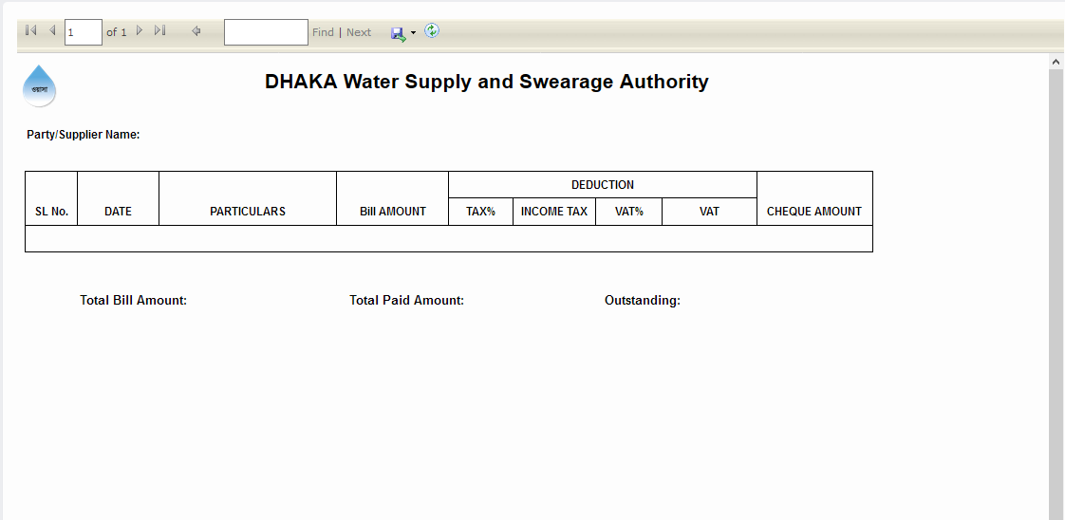

**6. Employee advance register:**In this page, employee bill register history will be displayed.

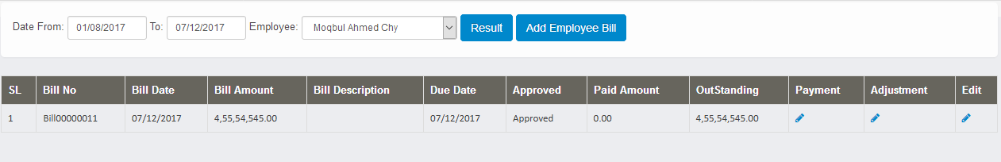

Add Employee Bill:To add employee bill, need to click on “Add employee bill” Button.

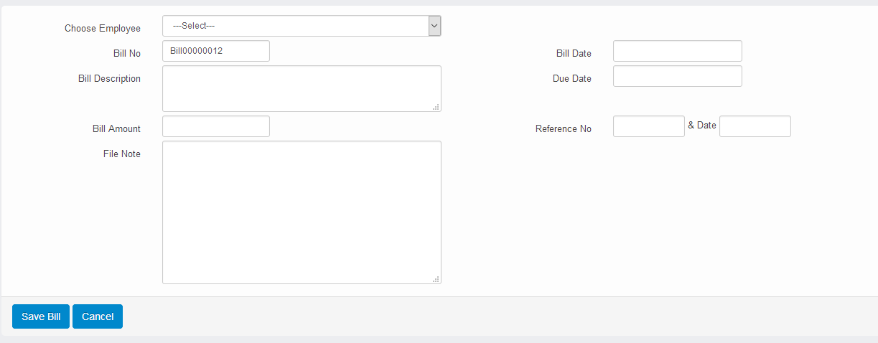

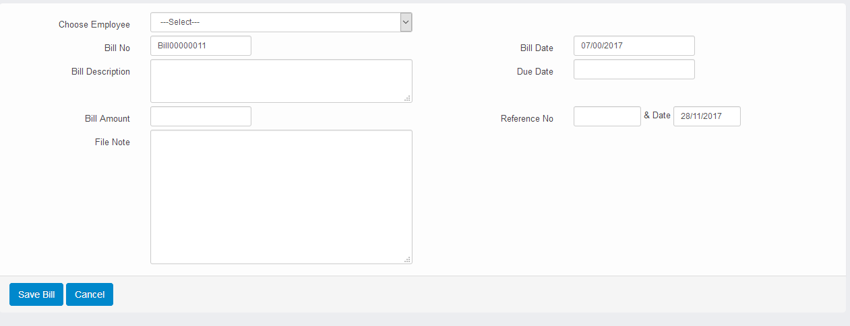

Edit Employee Bill Register: To edit employee bill register, need to click on edit button of “Edit” column from the employee bill register page. Then edit window will show. After changing information, need to click on save button.

Payment Bill: For advance bill payment, need to click on the payment button of “Payment Column” from the employee bill register page. Then payment Window will show.

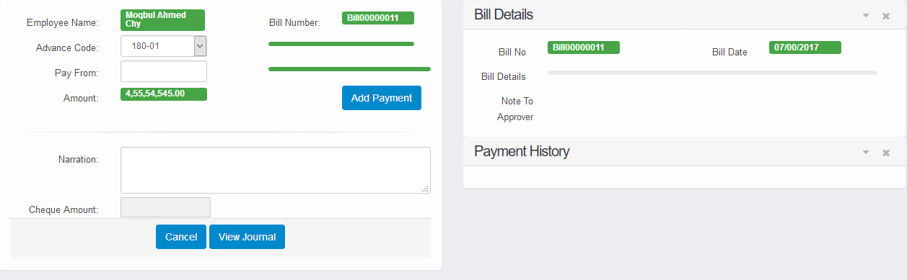

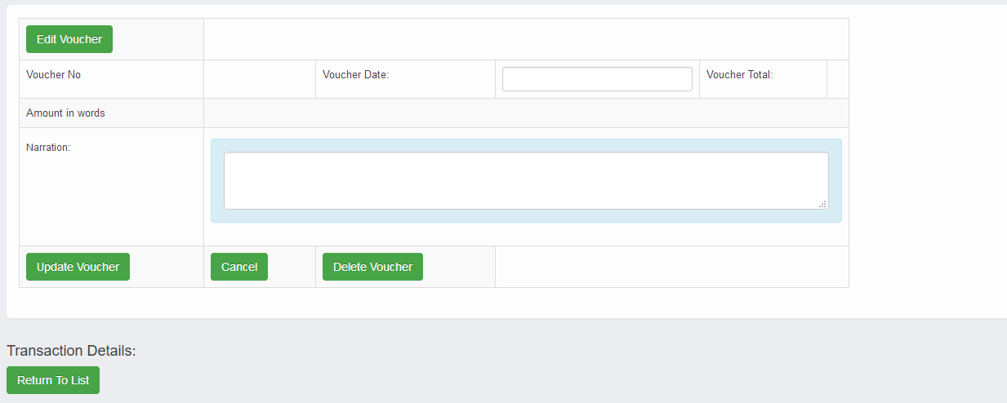

**View Voucher:** By clicking view voucher detail button, View voucher window will open.

**Adjustment:**By clicking adjustment button from adjustment column, below window will open.

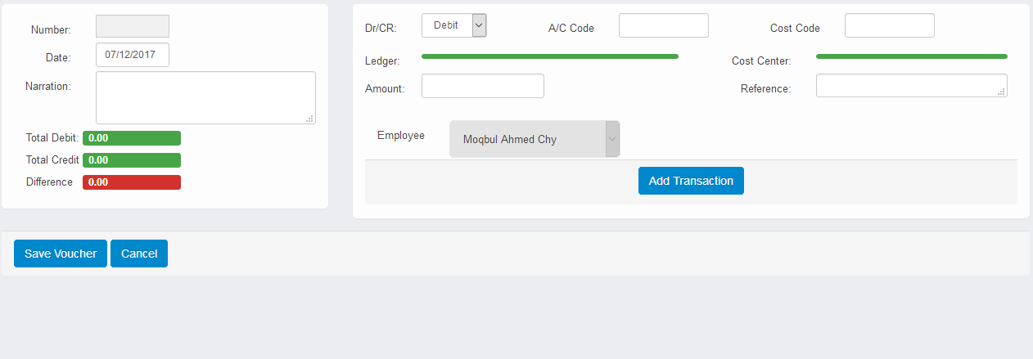

**7. Adjustment of advance:**In this page advance adjustment list will be displayed.

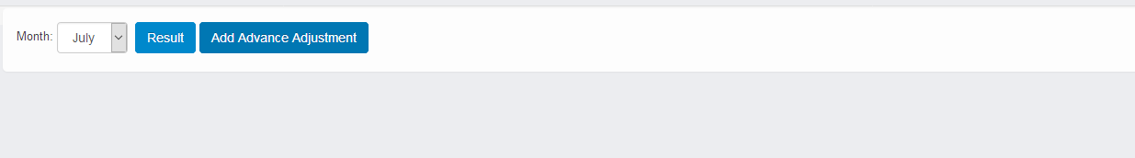

**Add Adjustment:** To add adjustment need to click on “Add Adjustment” button.

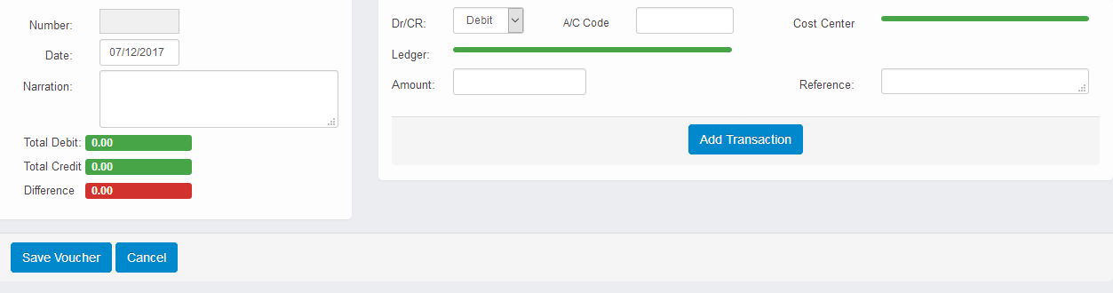

**8. Vat Deduction List:**In this page, List of VAT are displayed.

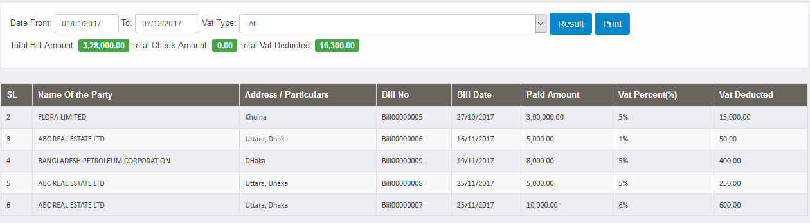

**Printing:**  By clicking print button, we will get vat deduction list.

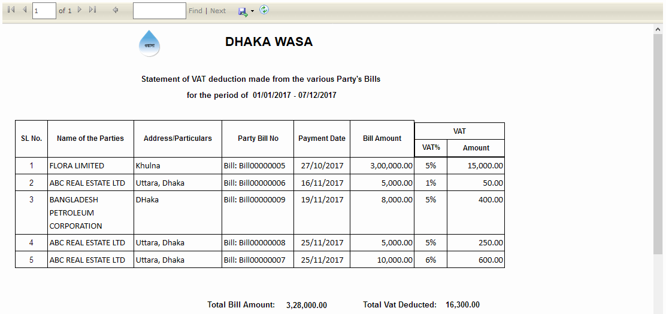

**9. AIT Deduction List:**In this page, List of AIT are displayed.

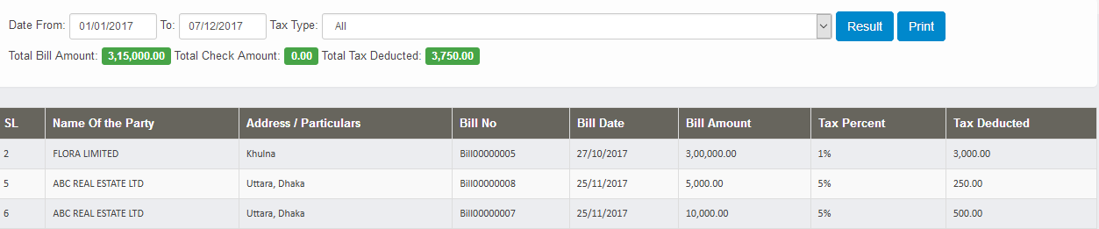

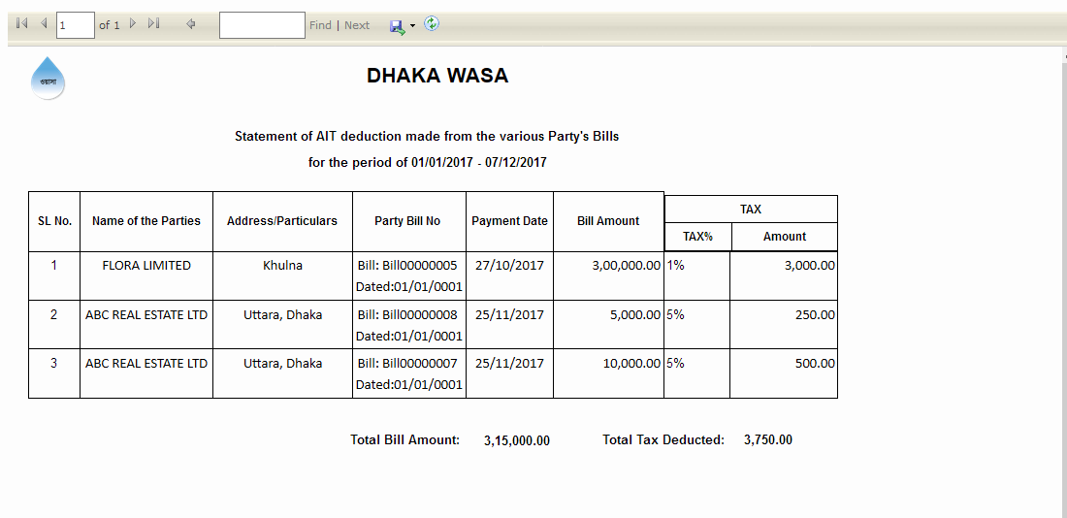

**Printing:** By clicking print button, we will get vat deduction list.

**10. Update Vat Challan:** In this page, vat challan list will displayed, and user can update the Vat challan.

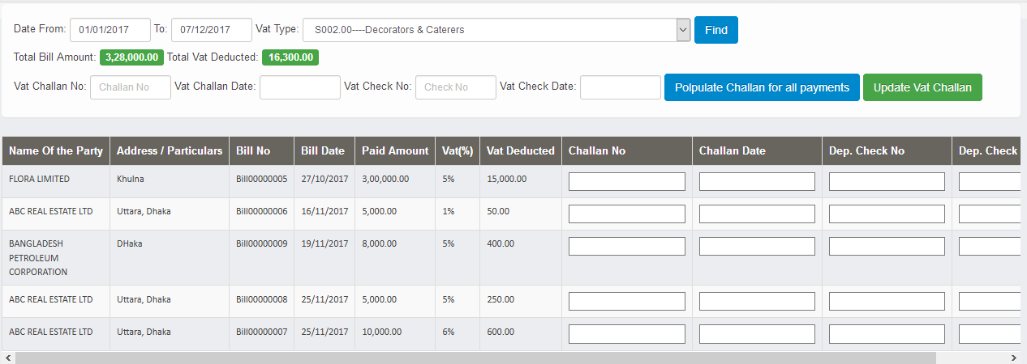

Updating Challan: After inserting required fields, need to click on “update vat challan” button to update the information.

**11. Update AIT Challan:** In this page, AIT challan list will displayed, and user can update the AIT challan.

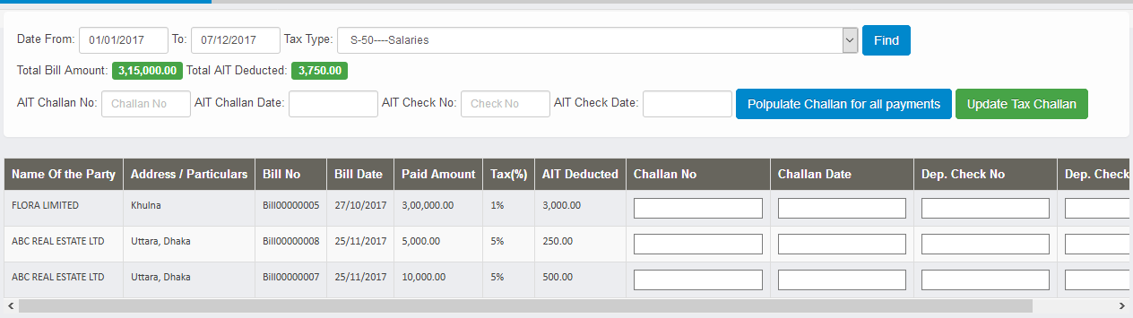

Updating Challan: After inserting required fields, need to click on “Update Tax Challan” button to update the information.

**12. Vat Certificates:**In this page, Supplier vat list/ certificate will be displayed.

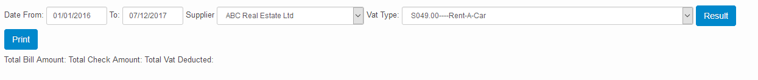

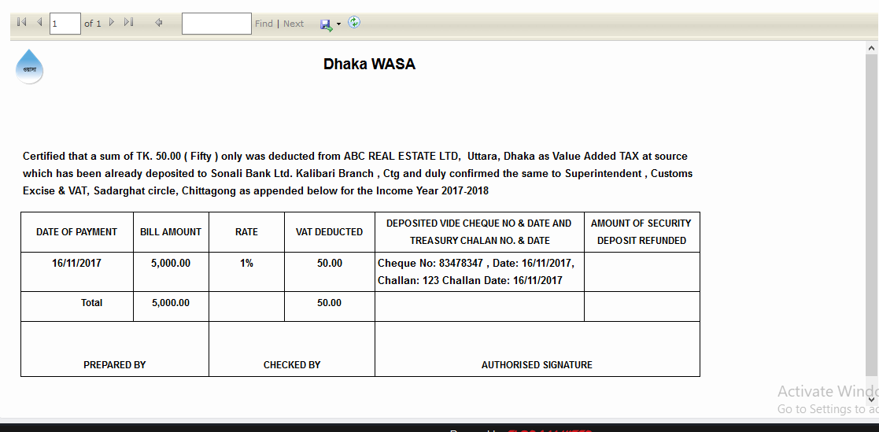

**Daily Transaction**

**1. Payment Voucher Listing:**In this page, the list of payment voucher list will be shown.

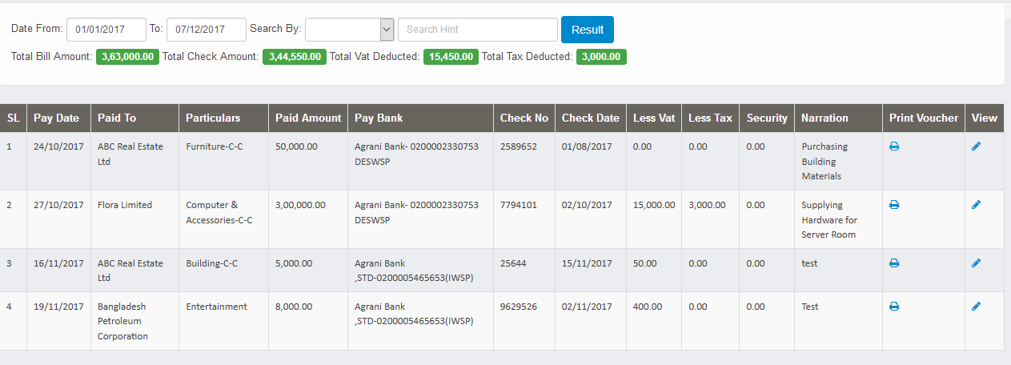

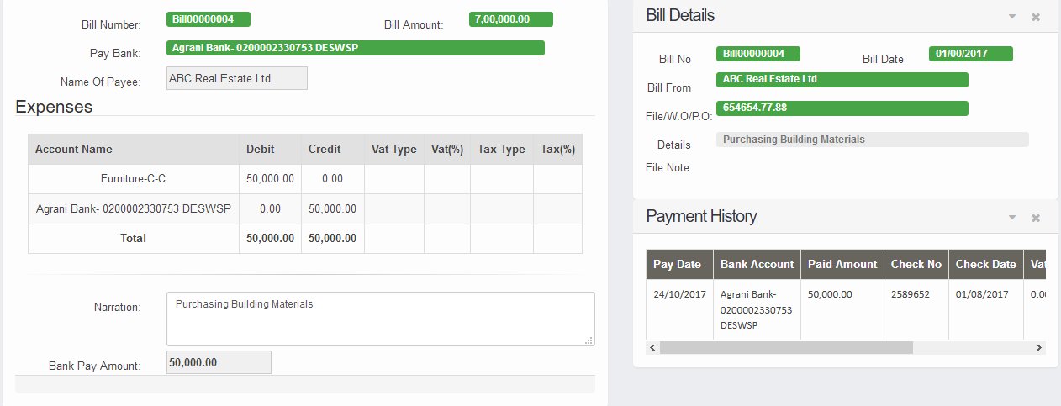

**Print Voucher:**  By clicking print button from Print column, user can view the bank payment voucher

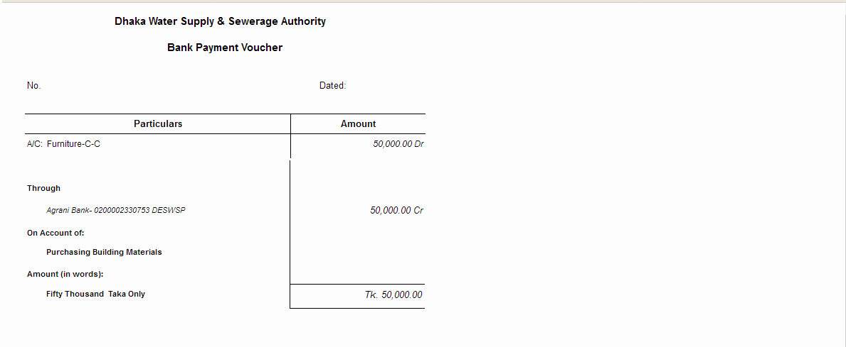

**View voucher:** By clicking view button from view column, user can view the payment voucher.

**2. Receipt Vouchers Listing:** In this page, receipt voucher listing will show based on between two date period.

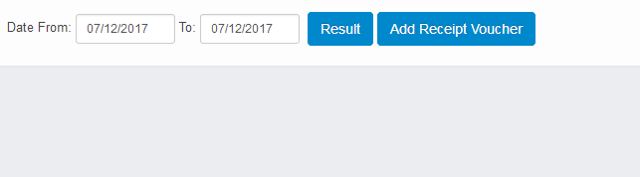

**Add receipt voucher:** By Clicking add receipt voucher button, below ad screen will appear.

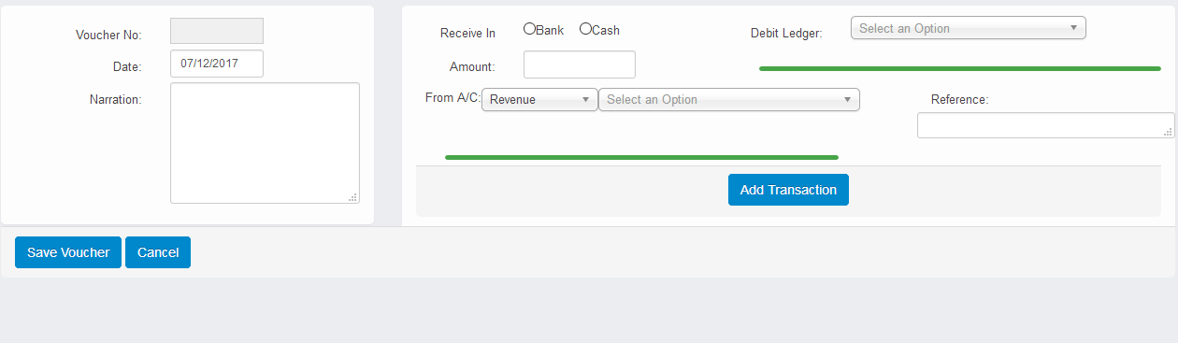

**3. Contra Vouchers Listing:** In this page, contra voucher listing will show based on between two date period.

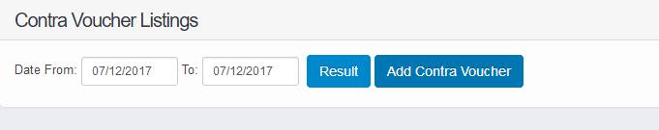

**Add contra voucher:** By Clicking add contra voucher button, below ad screen will appear.

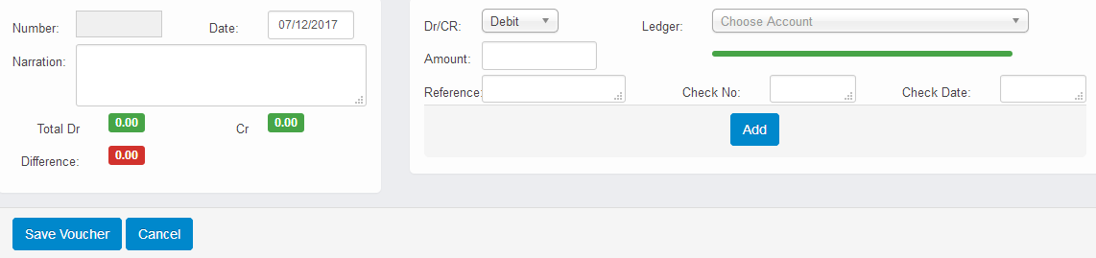

**3. Journal Vouchers Listing:** In this page, journal voucher listing will show based on between two date period.

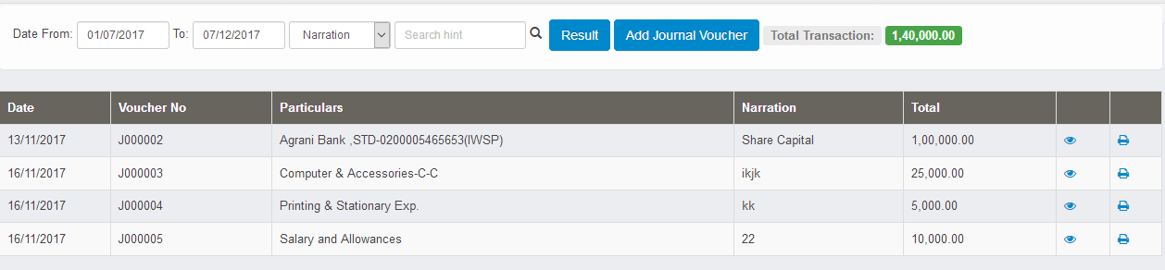

**Add journal voucher:** By Clicking add journal voucher button, below ad screen will appear.

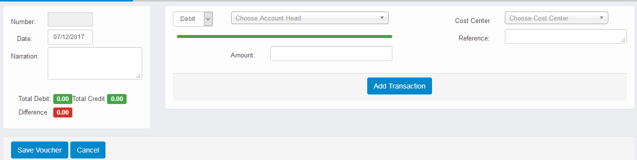

**4. Purchase Vouchers Listing:** In this page, purchase voucher listing will show based on between two date period.

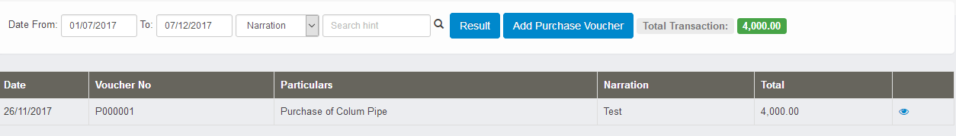

**Add purchase voucher:** By Clicking add purchase voucher button, below ad screen will appear.

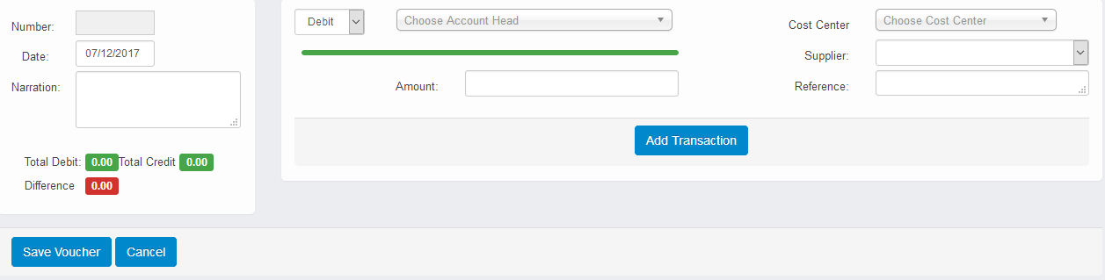

**5. Sales Vouchers Listing:** In this page, sales voucher listing will show based on between two date periods.

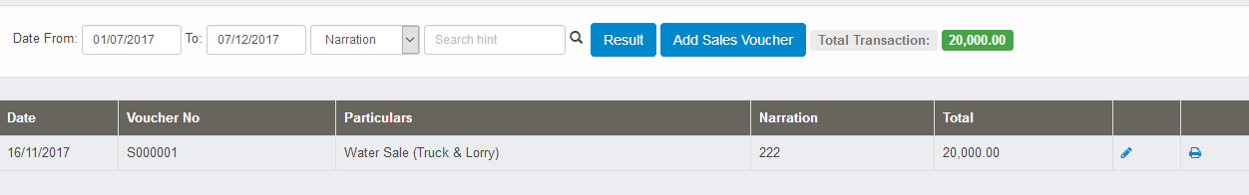

**Add purchase voucher:** By Clicking add purchase voucher button, below ad screen will appear.

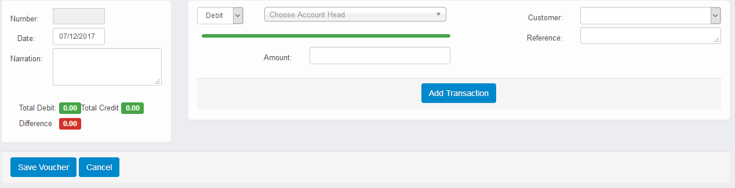

**6. Debit note Listing:** In this page, debit note listing will show based on between two date period.

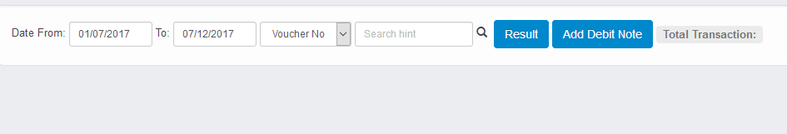

**Add purchase voucher:** By Clicking add debit note button, below ad screen will appear.

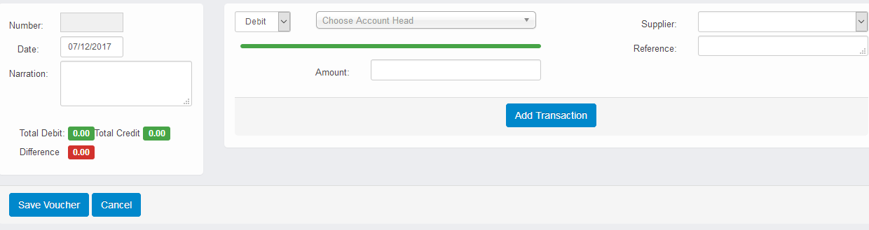

**7. Credit note Listing:** In this page, credit note listing will show based on between two date period.

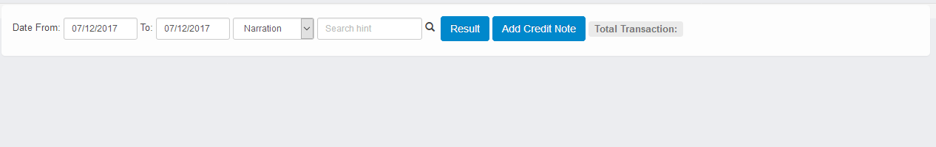

**Add purchase voucher:** By Clicking add credit note button, below ad screen will appear.

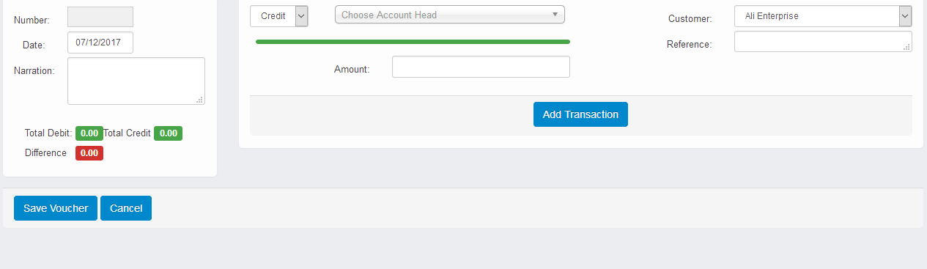

**Monthly Transaction**

**1. Bank Reconciliation:** In this page, bank reconciliation can be added

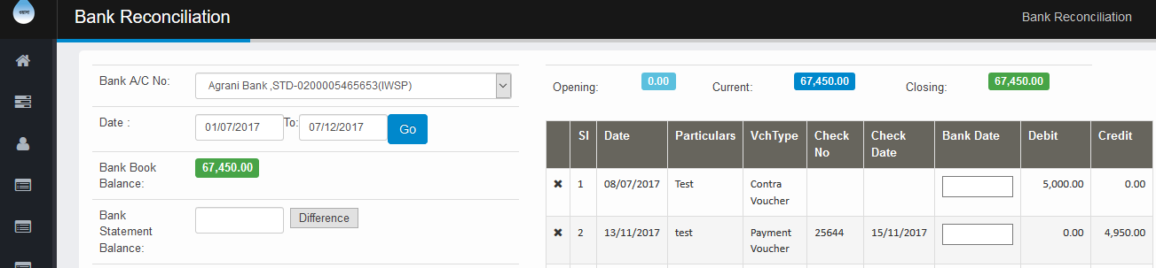

**2. Charge Dedication for this month:** In this page, Charge Dedication for a specific date

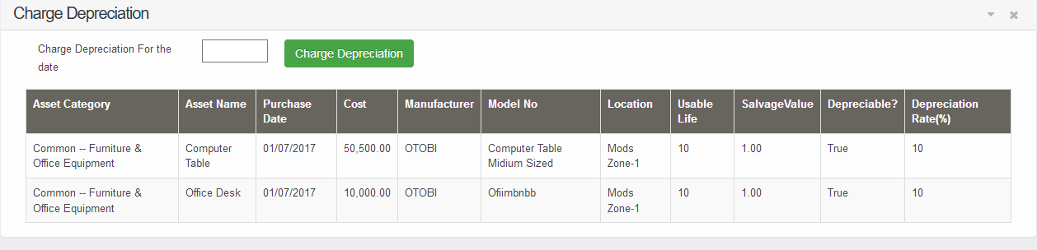

**Fixed Asset Management**

## 1. Fixed Asset Listings: Thelist of all fixed asset is shown in this list which you can manage through fixed asset acquisition.

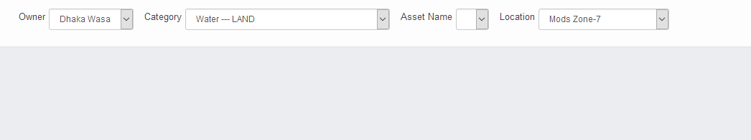

## 2. Fixed Asset Acquisition: Whenever a fixed asset is purchased, user should entry the asset details, cost, Use status, Depreciation percentage etc to book in to the fixed asset register and automatically depreciation is calculated and charged monthly with other asset.

## 

**3. Asset Depreciation Schedule:** Select the fixed asset and you will find the full depreciation list from the beginning with accumulated depreciation amount and written down value.

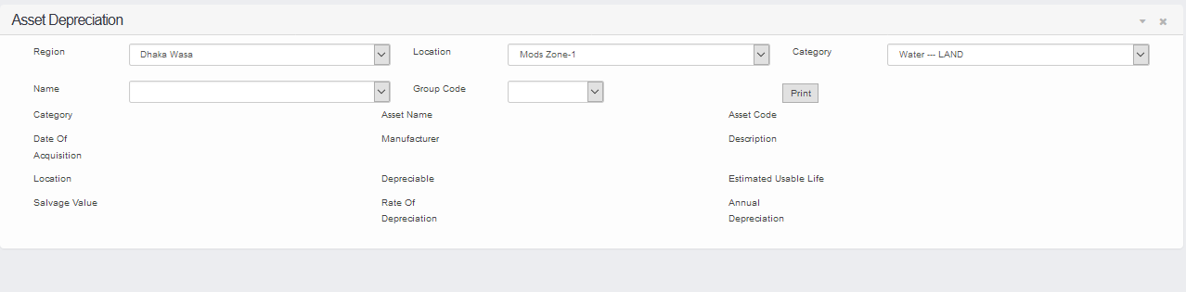

**4. Fixed Asset Transfer Relocation:** This Page will let user to add the fixed asset transfer relocation information.

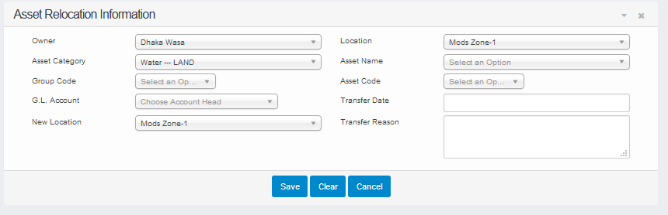

**5. Fixed Asset revaluation:** This Page will let user to add the asset transfer revaluation information.

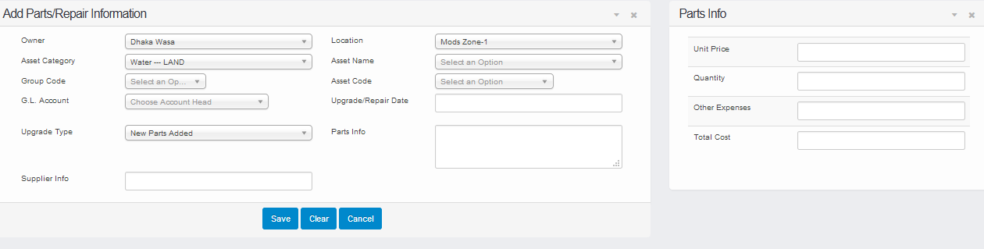

**6. Fixed Asset disposal:** This Page will let user to add the fixed asset disposal information.

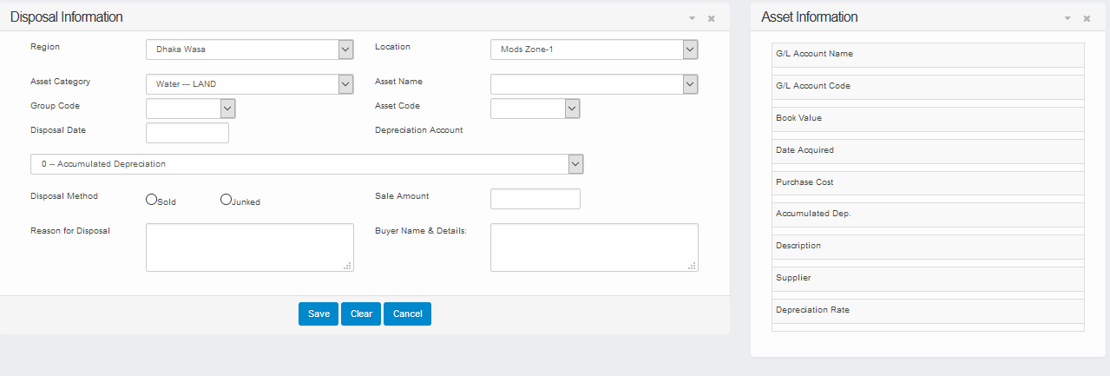

**Reports**

**1. Account Head wise budget:**

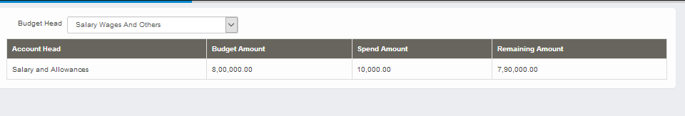

**2. Cost centre wise budget:**

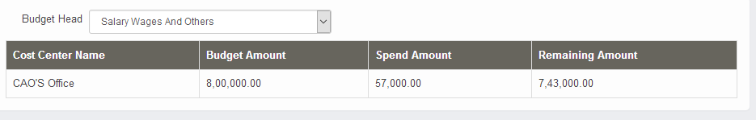

**3. Day Book**

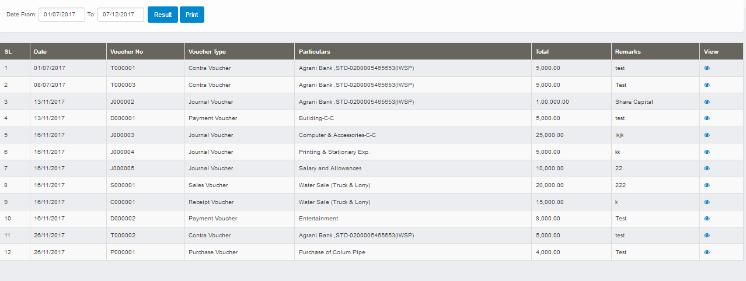

**4. Bank Book**

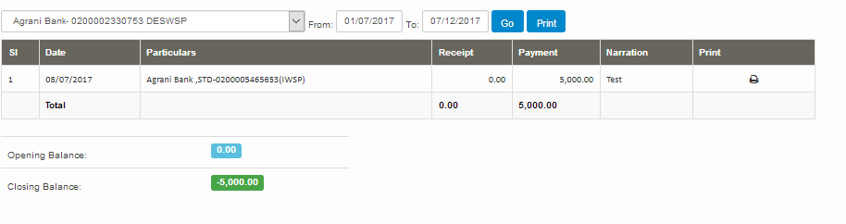

## 5. General Ledger

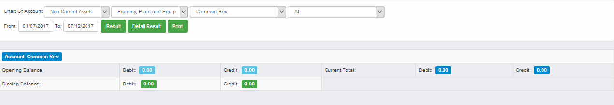

## 6. Trial Balance Report

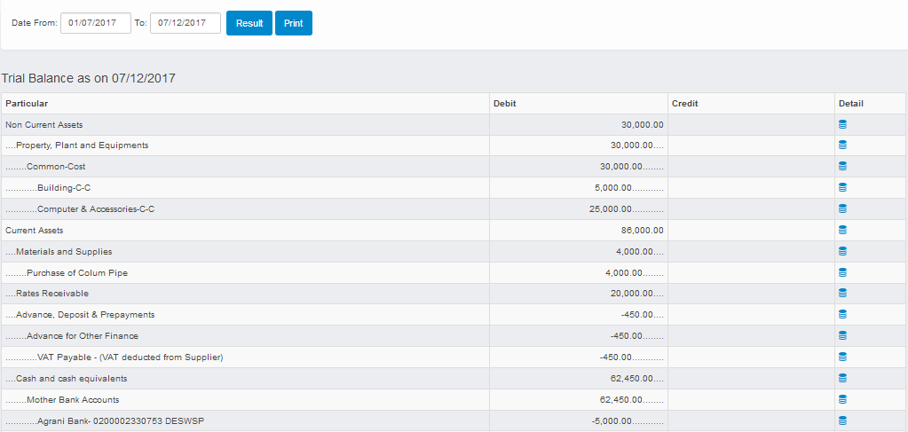

## 7. Income Statement

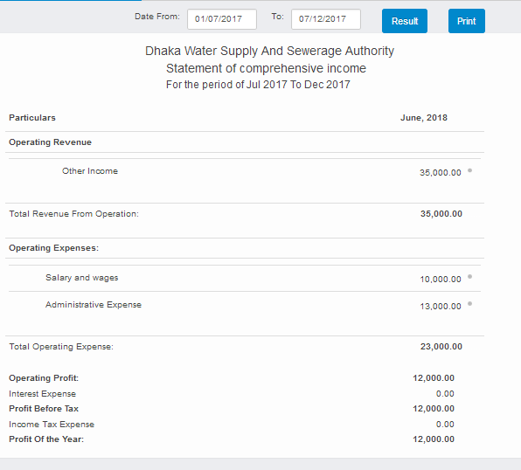

## 8. Balance Sheet

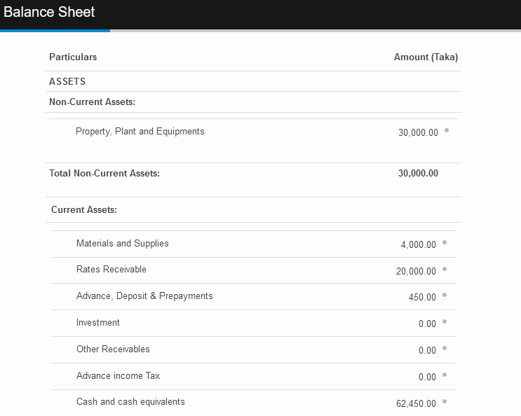

## 9. Cash Flow

## 

## 10. Chart of accounts listing

## 